**Client Sign-Off: Inception Phase**

I,**Daniel Heidt** , acknowledge that I have received all the stated deliverables and that they are at an acceptable quality to me.

Deliverables:

- Team Charter

- Project Charter with Event Table

- Project Plan

I also acknowledge receipt of the **Client Expectations letter** from the college.

_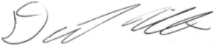________ x     Signed  Date: _______30 January 2019_________________.